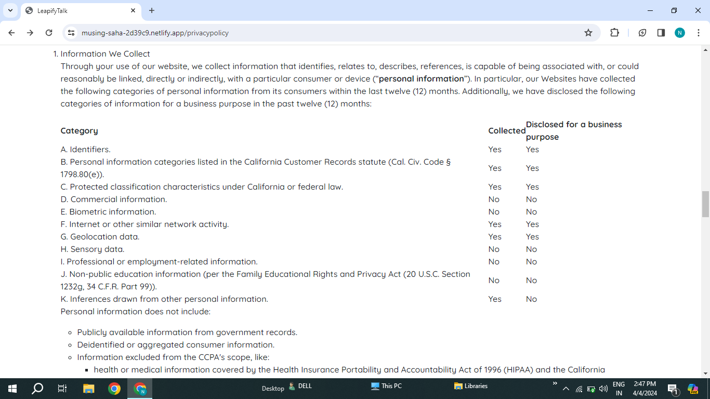

It should be in table manner to differentiate the text.